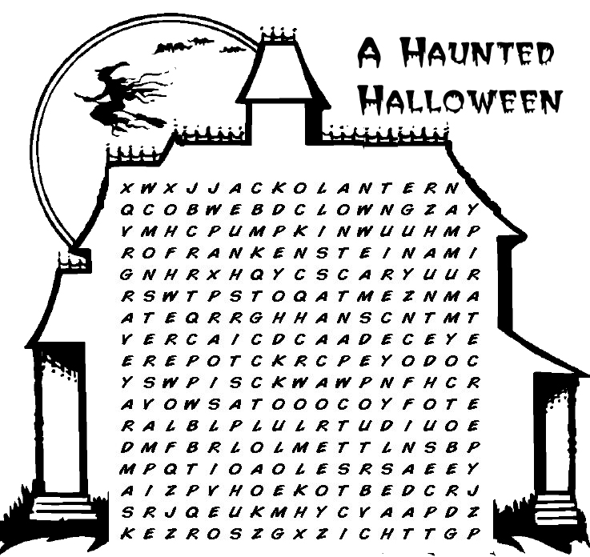
 | bat  black cat  broom  candy clown  cobweb | coffin  costume  creepy  Dracula  Frankenstein  ghost  graveyard | Halloween  happy  haunted house  jack-o'-lantern  mask  monster  mummy | October  party  pillowcase  pirate  pumpkin  scary | skeleton  spooky  trick-or-treat  vampire  werewolf  witch
