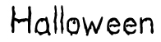 |  | 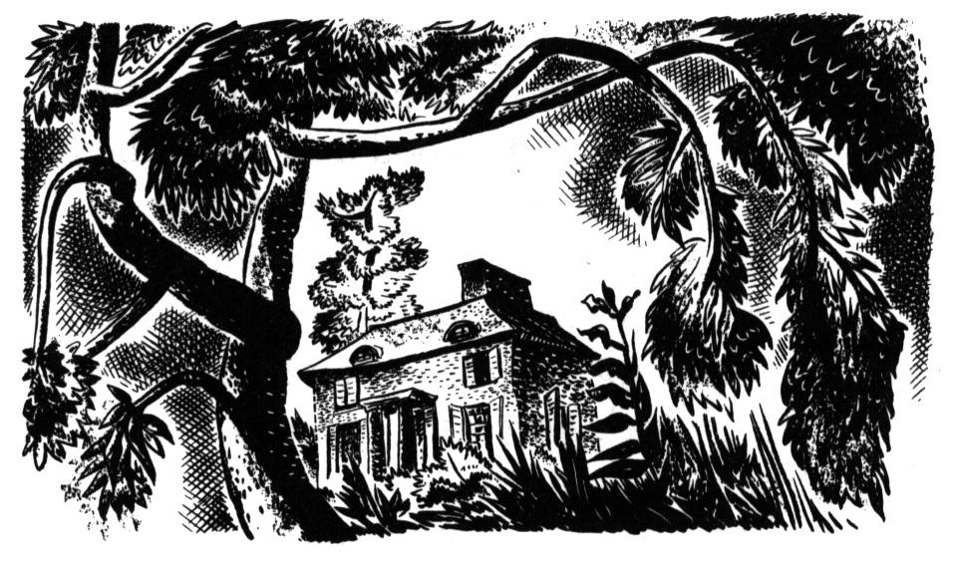  The house on the hill in the old forest.
I went trick-or-treating with my best friends and our pillowcases were full of candy, and it was getting late, so my friends wanted to go home.

I wanted a few more chocolate bars so I turned to my friends and said, “Let’s knock on a few more doors and then head for home.”

They were worried because they thought it was already too late. “Let’s go home now,” they said to me. I told them not to worry because we could take a shortcut through the old forest.

So after a few more houses, I took my friends to the path that went through the forest. We walked about 20 minutes, and then, suddenly, I felt very strange. I couldn’t remember the way! It was dark and foggy. We were lost. And to make matters worse, it started to rain. And then, it started to pour. Lightning lit up the sky and thunder rang in our ears. We wandered around in the rain for over two hours. We were very wet and very cold. And then, at about midnight, I saw an old abandoned house on a hill.

“I think we’ll have to spend the night in that old house and wait till morning,” I said.

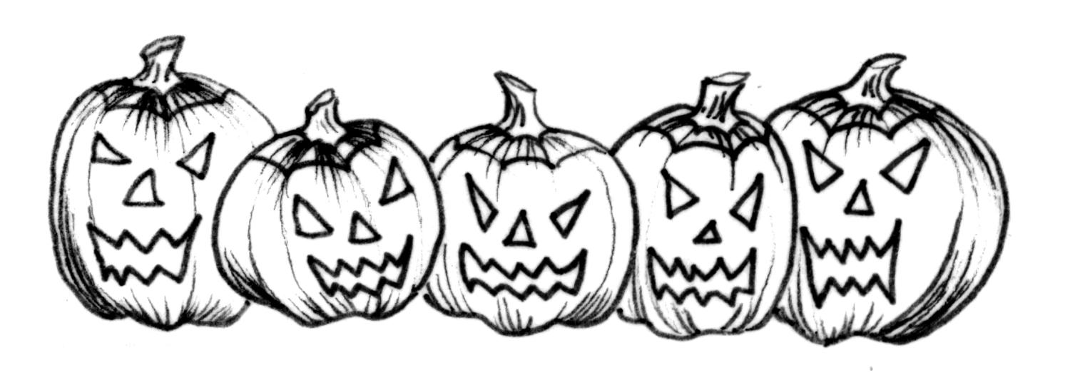 | My friends didn’t think it was a good idea, but they were cold and wet, so they agreed. We walked up the old wooden steps to the front door. The door creaked open and we went inside, sat down, and started to eat a chocolate bar, when . . .

Reading Comprehension:  What is happening at the beginning of the story?  Why did the writer want to go to a few more houses?  Why didn’t the writer worry because it was getting late? |  |  |  |  | 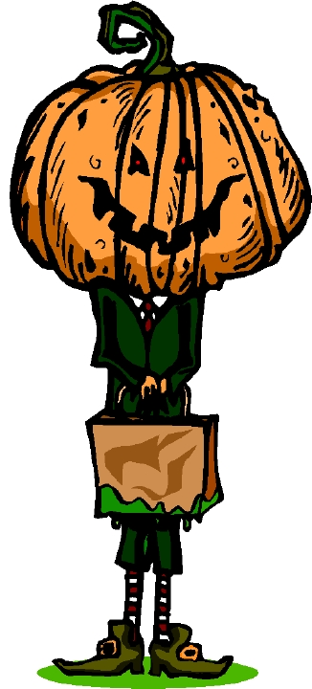
What happened in the forest?

What was the weather like in the forest?

Did the writer’s friend think it was a good idea to stay in the house?

Why did the friends agree to stay at the house?

What did they do as soon as they went into the house?

Match the following words with their definition:
abandoned |  | wander |  | shortcut |  |  | pour
______________ A quicker way to get somewhere.
______________ Go from place to place.
______________ Rain very hard.
______________ Empty with no one living there.

Finish writing the story using all the phrases in the box below.
Creative Writing Box |  |  | screamed  saw a light  ran down the hall |  |  | cobwebs  heard footsteps  hid under the bed
heard a noise
dawn

