
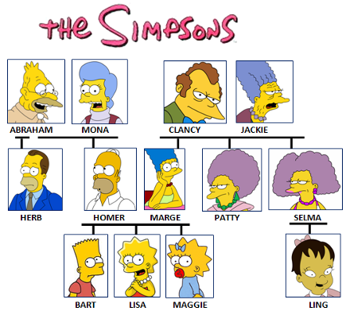

Simpsons Family Quiz
How much do you know about the Simpsons Family? Read the sentences and circle the correct options. The picture below might help you.

___ | 25
1. Bart is Lisa’s
a) sonb) brother
2. Marge is Homer’s
a) sisterb) wife
3. Clancy is Selma’s
a) fatherb) uncle
4. Abraham is Mona’s
a) husbandb) brother
5. Maggie is Ling’s
a) cousinb) sister
6. Lisa is Patty’s
a) auntb) niece
7. Homer is Abraham’s
a) fatherb) son
8. Selma is Ling’s adoptive
a) motherb) daughter
9. Bart is Herb’s
a) nephewb) uncle
10. Maggie is Marge’s
a) daughterb) mother
11. Herb is Marge’s
a) brotherb) brother-in-law
12. Patty is Selma’s
a) sisterb) half-sister
13. Herb is Homer’s
a) half-brotherb) cousin
14. Abraham is Marge’s
a) fatherb) father-in-law
15. Herb is Maggie’s
a) uncleb) nephew
16. Jackie is Homer’s
a) motherb) mother-in-law
17. Marge is Herb’s
a) sister-in-lawb) sister
18. Homer and Marge are Lisa’s
a) fathersb) parents
19. Homer is Clancy’s
a) son-in-lawb) son
20. Bart and Lisa are Maggie’s
a) brothersb) siblings
21. Abraham is Lisa’s
a) grandfatherb) father-in-law
22. Bart and Lisa are Marge’s
a) childrenb) grandchildren
23. Maggie is Jackie’s
a) grandmotherb) granddaughter
24. Marge is Mona’s
a) daughter-in-lawb) daughter
25. Clancy and Jackie are Bart’s
a) parents-in-lawb) grandparents
Simpsons Family Quiz
How much do you know about the Simpsons Family? Read the sentences and circle the correct options. The picture below might help you.

___ | 25
1. Bart is Lisa’s
a) sonb) brother
2. Marge is Homer’s
a) sisterb) wife
3. Clancy is Selma’s
a) fatherb) uncle
4. Abraham is Mona’s
a) husbandb) brother
5. Maggie is Ling’s
a) cousinb) sister
6. Lisa is Patty’s
a) auntb) niece
7. Homer is Abraham’s
a) fatherb) son
8. Selma is Ling’s adoptive
a) motherb) daughter
9. Bart is Herb’s
a) nephewb) uncle
10. Maggie is Marge’s
a) daughterb) mother
11. Herb is Marge’s
a) brotherb) brother-in-law
12. Patty is Selma’s
a) sisterb) half-sister
13. Herb is Homer’s
a) half-brotherb) cousin
14. Abraham is Marge’s
a) fatherb) father-in-law
15. Herb is Maggie’s
a) uncleb) nephew
16. Jackie is Homer’s
a) motherb) mother-in-law
17. Marge is Herb’s
a) sister-in-lawb) sister
18. Homer and Marge are Lisa’s
a) fathersb) parents
19. Homer is Clancy’s
a) son-in-lawb) son
20. Bart and Lisa are Maggie’s
a) brothersb) siblings
21. Abraham is Lisa’s
a) grandfatherb) father-in-law
22. Bart and Lisa are Marge’s
a) childrenb) grandchildren
23. Maggie is Jackie’s
a) grandmotherb) granddaughter
24. Marge is Mona’s
a) daughter-in-lawb) daughter
25. Clancy and Jackie are Bart’s
a) parents-in-lawb) grandparents

