BLACK OR WHITE
Click on this link to go to the video: http://www.youtube.com/watch?v=mqZnxvAPkL8
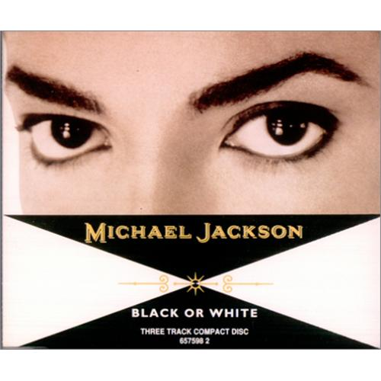
1. Choose the correct word or words to complete the song lyrics
I took my baby on a Saturday bang / night / club
hey / boy / Bob is that girl with you?
Yes, we're one / want / young and the same
Now I believe in fables / miracles / fantasies
and a Miracle has happened tonight / last night / this night
But, if you're thinkin' about my baby / lady / daddy
It won’t / don't / can’t matter if you're black or white
They print my sausage / paper/ message
in the Saturday Sun / sand / son
I had to tell them I ain't second to none / come / one
And I told about equality / economy / politics and it's true
either you're wrong or you're right / write / bright
2. Tick on the words that appear in the Rap Performance:

___ PROTECTION ___ CLUBS ___ HUMAN RELATIONS
___ POLITICS ___ ECONOMICS ___ NATIONS
___ PLACES ___ SCHOOL ___ FACES

3. Tick only the images you see on the video.

___ LIONS ___ FACTORIES ___ BIG BEN
___ A PLANE ___ A DINOSAUR ___ LOUDSPEAKERS
___ TAJ MAHAL ___ A GIRAFFE ___ A TRIBE
___ EIFFEL TOWER ___ A DOVE ___ GUNS

4. Write down four nationalities that appear on the video.

Can you think of more?

