HEROIS
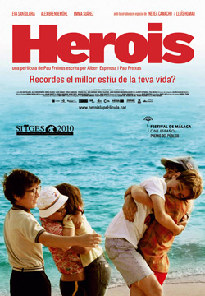

Last Sunday I went to the cinema with my friend Montse. We usually go to the cinema together once a month. We both like the same kind of films. We prefer comedies or romantic films to horror films.

This time we decided to see a premiere. It is a Catalan production. So at six o’clock I picked her up and off we went to the cinema. We bought the tickets and at twenty past six we were already sitting waiting for the film to start.

There are many reviews on the film, but I prefer to give my own. The action takes place in a village in the Costa Brava, in Catalonia. Even if it may seem quite a boring place, there is an old tree with magical powers. They say that during the war no one in the village died. Every summer there is a competition to see who is going to be the owner of the tree for a year. And so have their wishes come true. But this summer is different, especially for one of the boys, Xavi. But I’m not going to tell you why. I recommend you to go and see it.

You surely will enjoy it, no matter if you are a teenager or if you were in the 80s. And the soundtrack is simply fantastic. You can’t refrain from singing those songs as they play. I could tell you many more things about the film, but I won’t. Just one last piece of advice: don’t forget to have your handkerchief with you.

HEROIS



Last Sunday I went to the with my friend Montse. We usually


go to the cinema together once a month. We both like the same kind of. We prefer  or  to


This time we decided to see a premiere. It is a Catalan production. So at I picked her up and off we went to the cinema. We bought the  and at twenty past six we were already waiting for

the film to start.There are many reviews on the film, but I prefer to give my own. The action takes place in a  in the Costa Brava, in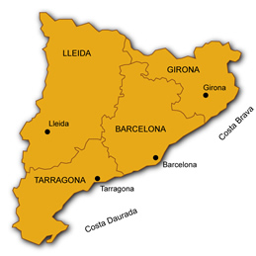. Even if it may seem quite a  place, there is an with magical powers.
They say that during the  no one in the village

Every summer there is a competition to see who is going to be the owner of the tree for a year. And so have their wishes come true. But this  is different, especially for one of the, Xavi. But I’m not going to tell

you why. I recommend you to go and see it. You surely will enjoy it, no matter if you are a teenager or if you were in the 80s. And the  is simply fantastic. You can’t refrain from singing those  as they play. I could

tell you many more things about the film, but I won’t. Just one last piece of advice: don’t forget to have your  with you.

