I Will Survive
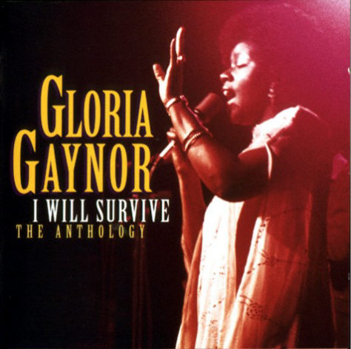
Listen to the song and fill in the gaps.  At first I was afraid, I was petrified  Kept thinkin' I could never (1) _________,  without you by my side.  But then I spent so many nights just thinkin' how  you did me wrong. And I grew (2) _________,  and I learned how to get along.  So now you're back, from outer space  I just walked in to find you here with  that sad look upon your face.  I should've changed that stupid lock,I should've  made you leave your (3) _________!  If I had known for just one second you'd  be back to bother me,  Go on now go, walk out the door  Just turn around now, cause  you're not (4) _________ anymore  Weren't you the one who tried  to hurt me with goodbye  Did I crumble, did I lay down and die  Oh no not I, I will survive  Oh, as long as I know how  to love, I know I'll stay (5) _________  & I've got all my life to live  & I've got all my love to give  I'll survive, I will survive  Hey, Hey!!!  It took all the strength i had,  not to fall apart,  just tryin hard to mend the pieces of  my broken (6) _________  And I spent so many nights just feelin'  sorry for myself, I used to cry  But now I hold my head up high  And you see me, somebody (7) _________  I'm not that chained up little  person still in love with you | And so you felt like droppin' in, and  just expect me to be (8) _________  But now I'm savin' all my lovin' for  someone who's lovin' me  Go on now go, walk out the door  Just turn around now, cause  you're not welcome anymore  Weren't you the one who tried  to break me with goodbye  Did I crumble, did I lay down and die  Oh no not I, I will survive  Oh, as long as I know how  to love I know I'll stay alive  I've got all my (9) _________ to live,  I've got all my love to give,  I'll survive, I will survive...  Oh.......  Go on now go, walk out the door  Just turn around now, cause  you're not welcome anymore  Weren't you the one who tried  to break me with goodbye,  Did you think I'd crumble,  Did you think I'd lay down and die  Oh no not I, I will survive  Oh, as long as I know how to (10) _________  I know I'll stay alive, I've got all  my life to live, I've got all my  love to give  I'll survive, I will survive  I will survive!!!

