TASK : Read the following texts about these people and HIGHLIGHT the simple present verbs : verb TO BE in red and verb TO HAVE (GOT) in green and all the OTHER VERBS in blue.

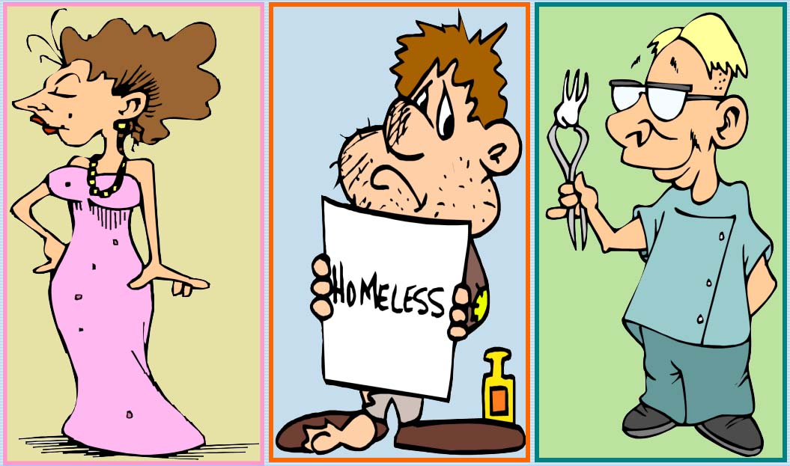
2

1
3

1
This is Carla Fellini. She´s a famous film star. She´s from Rome. She´s got a villa in Venice and a house in Rome with a big garden. She´s got five cars and a lot of money and jewels in the bank.
Her husband is Paul and they have a son and a daughter. Julia loves them. She likes her life! She has everything she could dream of!
This is David Reynolds. He was born in Paris but he lives in Manchester.
2
He´s broke. He hasn´t got any money. He´s unemployed. He doesn´t have a house or a car.
He´s not married. He doesn´t have any children, either. He feels miserable.
He doesn´t like his life. It´s terrible! He has nothing.

This is Paul Bridges. He isn’t from Rome or Paris. He´s from London. He´s a dentist. He´s got a good job.He has a small car and a motorbike.
3
He hasn´t got a villa, but he´s got a flat in the centre of town.
He´s got a wife. Her name´s Sue, but he hasn´t got any children. Life is OK for him.

