
The London Eye: Key

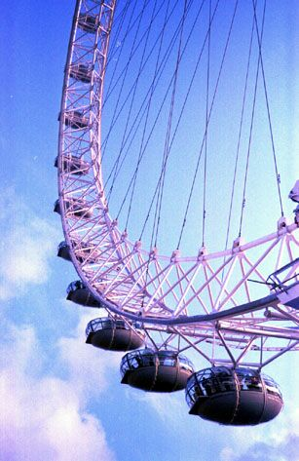
The London Eye (also known as the Millennium Wheel) at a height of 135 metres (443 ft), is the biggest Ferris wheel in Europe, and has become the most popular paid tourist attraction in the United Kingdom, visited by over 3 million people a year. At the time it was erected it was the tallest Ferris wheel in the world, until it was surpassed by the Star of Nanchang (160m) in May 2006, and then the Singapore Flyer (165m) on 11 February 2008. However, it is still described by its operators as "the world's tallest cantilevered observation wheel" (because the entire structure is supported by an A-frame on one side only).

The London Eye is located at the western end of Jubilee Gardens, on the South Bank of the River Thames in London, United Kingdom, between Westminster Bridge and Hungerford Bridge. The site is adjacent to that of the former Dome of Discovery, which was built for the Festival of Britain in 1951.

