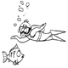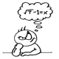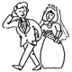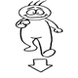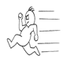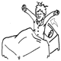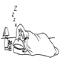
Write the verbs under each picture Name _______________________________

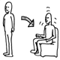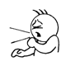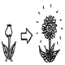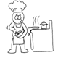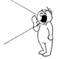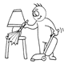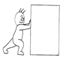

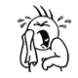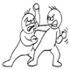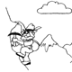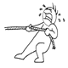

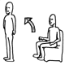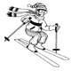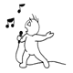

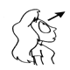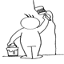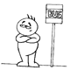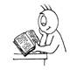

http://iteslj.org/v/ei/verbs1.html http://iteslj.org/v/ei/verbs2.html http://iteslj.org/v/ei/verbs3..html

