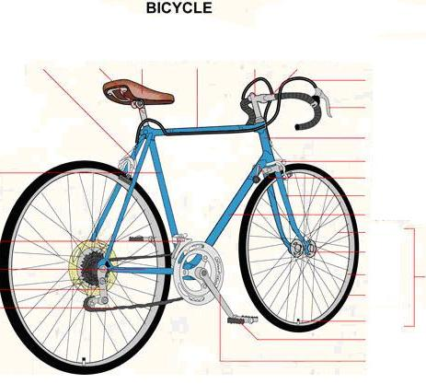
GO TO THIS WEBSITE http://www.infovisual.info/
LOOK IN TRANSPORT
FIND THE BICYCLE
WRITE THE NAMES OF THE COMPONENTS

